Doug Strouth

CIS228

Chapter 4 City Jail exercise

I screenshot the Object browser’s list of constraints for each table because eunlike the last chapter there was no quick sql command to list the constraint types. Also, because of length limitations for the identifiers the constraints of Code_description and the composite key of the Crime_officers table both have abbreviated non-standard names. I hope this is alright.

**SQL Code:**

DROP TABLE Appeals;

DROP TABLE Crime_officers;

DROP TABLE Crime_charges;

ALTER TABLE Crime_codes

ADD CONSTRAINT Crime_codes_Crime_code_pk PRIMARY KEY(Crime_code);

ALTER TABLE Crime_codes

MODIFY (Code_description CONSTRAINT Crime_codes_Code_descrip_nn NOT NULL);

ALTER TABLE Crime_codes

ADD CONSTRAINT Crime_codes_Code_descrip_uk UNIQUE(Code_description);

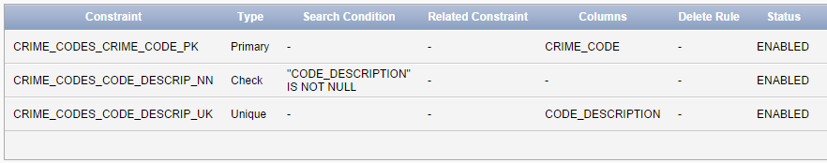

ALTER TABLE Criminals

ADD CONSTRAINT Criminals_Criminal_ID_pk PRIMARY KEY(Criminal_ID);

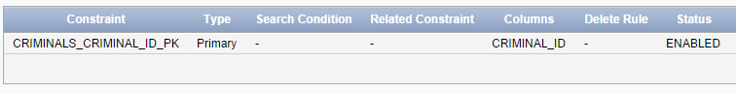

ALTER TABLE Officers

ADD CONSTRAINT Officers_Officer_ID_pk PRIMARY KEY(Officer_ID);

ALTER TABLE Officers

ADD CONSTRAINT Officers_Badge_uk UNIQUE(Badge);

ALTER TABLE Officers

MODIFY( Precinct CONSTRAINT Officers_Precinct_nn NOT NULL);

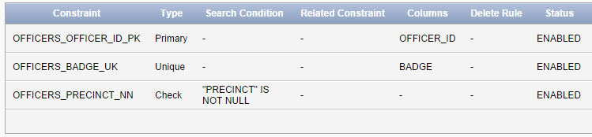

ALTER TABLE Prob_officers

ADD CONSTRAINT Prob_officers_Prob_ID_pk PRIMARY KEY(Prob_ID);

ALTER TABLE Prob_officers

MODIFY (STATUS CONSTRAINT Prob_officers_Status_nn NOT NULL);

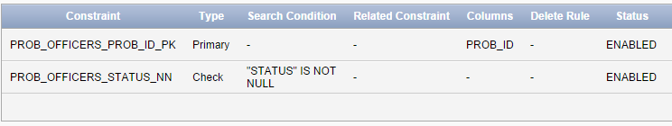

ALTER TABLE Crimes

ADD CONSTRAINT Crimes_Crime_ID_pk PRIMARY KEY(Crime_ID);

ALTER TABLE Crimes

ADD CONSTRAINT Crimes_Hearing_date_ck CHECK(Hearing_date>Date_charged);

ALTER TABLE Crimes

MODIFY (Status CONSTRAINT Crimes_Status_nn NOT NULL);

ALTER TABLE Crimes

ADD CONSTRAINT Crimes_Criminal_ID_fk FOREIGN KEY(Criminal_ID)

REFERENCES Criminals(Criminal_ID);

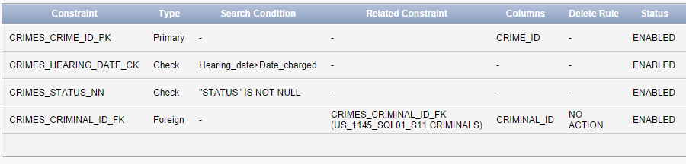

ALTER TABLE Aliases

ADD CONSTRAINT Aliases_Alias_ID_pk PRIMARY KEY(Alias_ID);

ALTER TABLE Aliases

ADD CONSTRAINT Aliases_Criminal_ID_fk FOREIGN KEY(Criminal_ID)

REFERENCES Criminals(Criminal_ID);

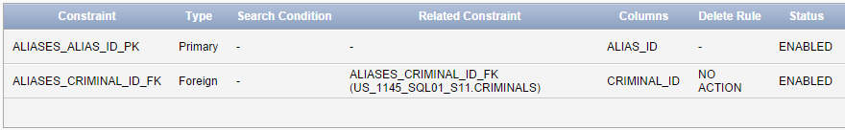

ALTER TABLE Sentences

ADD CONSTRAINT Sentences_Sentence_ID_pk PRIMARY KEY(Sentence_ID);

ALTER TABLE Sentences

ADD CONSTRAINT Sentences_End_date_ck CHECK(End_date>Start_date);

ALTER TABLE Sentences

MODIFY (Violations CONSTRAINT Sentences_Violations_nn NOT NULL);

ALTER TABLE Sentences

ADD CONSTRAINT Sentences_Criminal_ID_fk FOREIGN KEY(Criminal_ID)

REFERENCES Criminals(Criminal_ID);

ALTER TABLE Sentences

ADD CONSTRAINT Sentences_Prob_ID_fk FOREIGN KEY(Prob_ID)

REFERENCES Prob_officers(Prob_ID);

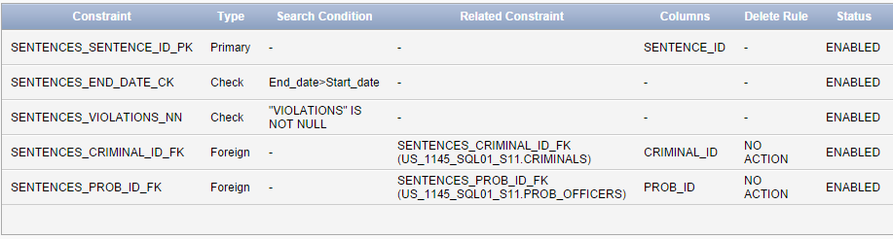

CREATE TABLE Appeals

(Appeal_ID NUMBER(5),

Crime_ID Number(9,0),

Filing_date DATE,

Hearing_date DATE,

Status CHAR(1) DEFAULT 'P',

CONSTRAINT Appeals_Appeal_ID_pk PRIMARY KEY(Appeal_ID),

CONSTRAINT Appeals_Crime_ID_fk FOREIGN KEY(Crime_ID)

REFERENCES Crimes(Crime_ID));

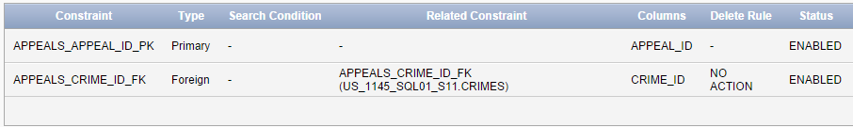

CREATE TABLE Crime_officers

(Crime_ID NUMBER(9,0),

Officer_ID NUMBER(8,0),

CONSTRAINT Crime_o_CrimeOfficerID_pk PRIMARY KEY(Crime_ID, Officer_ID));

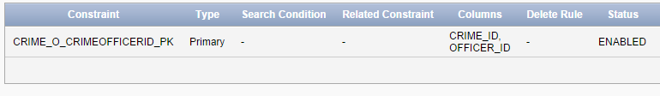

CREATE TABLE Crime_charges

(Charge_ID NUMBER(10,0),

Crime_ID NUMBER(9,0),

Crime_code NUMBER(3,0),

Charge_status CHAR(2),

Fine_amount NUMBER(7,2),

Court_fee NUMBER(7,2),

Amount_paID NUMBER(7,2),

Pay_due_date DATE,

CONSTRAINT Crime_charges_Charge_ID_pk PRIMARY KEY(Charge_ID),

CONSTRAINT Crime_charges_Crime_ID_fk FOREIGN KEY(Crime_ID)

REFERENCES Crimes(Crime_ID),

CONSTRAINT Crime_charges_Crime_code_fk FOREIGN KEY (Crime_code)

REFERENCES Crime_codes(Crime_code));

